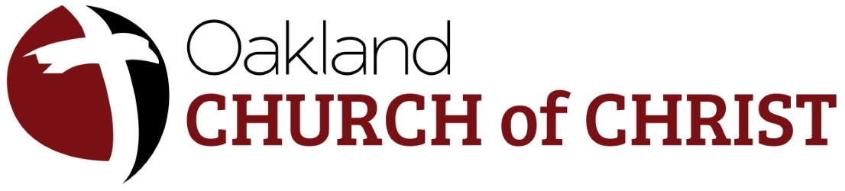 Prayer Ministry
Agenda
February 22, 2026 – 8pm
Ministry Leader: Menorvia Ross (313) 333-4755
Join online for Video and Screen Sharing: https://join.freeconferencecall.com/brazierprayer
Dial-in number (US): (681) 999-0247 Access code: 986436

- Opening Prayer
For where two or three are gathered together in My name, I am there in the midst of them. Matthew 18:20 NKJ
- Identify your Area
- Events, Brainstorm
- T-Shirt
- Closing Prayer.

